The activities of the Astronomical Institute of the Slovak Academy of Sciences (AISAS), Tatranská Lomnica (www.astro.sk), related to COSPAR, were devoted to research in stellar, solar, and interplanetary physics using different satellite observations, mainly in the UV, XUV and X-ray spectral regions. Stellar data of the Swift, XMM-Newton, TESS, CHEOPS, and Kepler satellites, were used for research of various variable stars [1,3,4,5,8,10,18], stars hosting exoplanets and the exoplanets themselves [2,9,11,12,13,14,15,16,17]. Data of the current SDO, IRIS, STEREO, Hinode, and other satellites were used for solar research. In common, these data were used with the simultaneously acquired data by the ground-based solar telescopes [6,19,20,21,22,23]. Different topics of the solar system bodies have been addressed, in many articles from the laboratory phyics side [7,24,25,26,27,28,29,30]. Hereby we present some examples of the results obtained by the AISAS staff.
Accretion of mass onto a white dwarf (WD) in a binary system can lead to stellar explosions. If a WD accretes from stellar wind of a distant evolved giant in a symbiotic binary, it can undergo occasional outbursts in which it brightens by several magnitudes, produces a low- and high-velocity mass outflow, and, in some cases, ejects bipolar jets. In paper [1] the current picture of these outbursts is complemented by the transient emergence of a neutral region in the orbital plane of symbiotic binaries consisting of wind from the giant. Its presence was proved by determining H0 column densities (NH) in the direction of the WD and at any orbital phase of the binary by modeling the continuum depression around the Lyα line caused by Rayleigh scattering on atomic hydrogen for all suitable objects, i.e., eclipsing symbiotic binaries, for which a well-defined ultraviolet spectrum from an outburst is available. The NH values follow a common course along the orbit with a minimum and maximum of a few times 1022 and 1024 cm−2 around the superior and inferior conjunction of the giant, respectively. Its asymmetry implies an asymmetric density distribution of the wind from the giant in the orbital plane with respect to the binary axis. The neutral wind is observable in the orbital plane owing to the formation of a dense disk-like structure around the WD during outbursts, which blocks ionizing radiation from the central burning WD in the orbital plane.

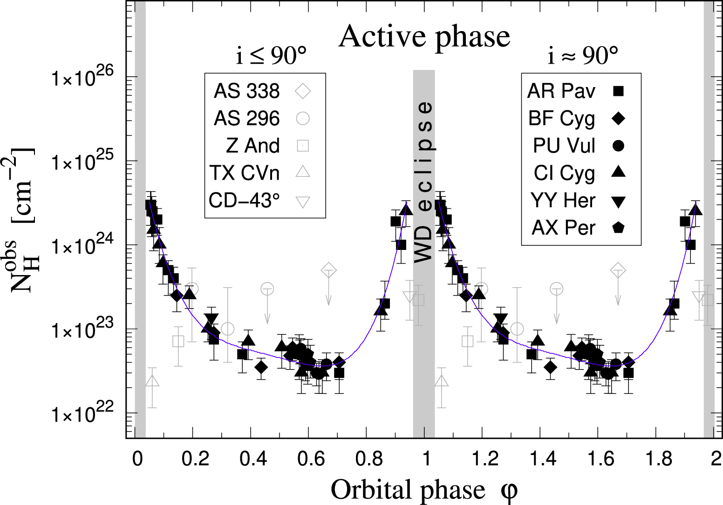
Figure 1. Column densities of atomic hydrogen, N_{H}^{obs}, between the observer and the WD, measured for our targets during active phases as a function of the orbital phase φ. For better visualization, the values are plotted over two orbital cycles. Eclipsing objects (black filled symbols) follow a common course. The blue line indicates their fit with a fourth-degree polynomial. Open gray symbols denote values for objects with poorly defined UV spectra (AS 338, AS 296) or not eclipsing, but with a high orbital inclination (Z And, TX CVn, CD −43°14304 (CD−43° in the legend)).

Based on the combined TESS and CHEOPS observations [2], the true orbital period of the planet d of the star HD 22946 (late F-type star) was successfully determinedt o be 47.42489 ± 0.00011 days, precise radii of the planets in the system were derived, namely 1.362 ± 0.040 R⊕, 2.328 ± 0.039 R⊕, and 2.607 ± 0.060 R⊕ for planets b, c, and d, respectively. Due to the low number of radial velocities, it was possible to determine only 3σ upper limits for these respective planet masses, which are 13.71 M⊕, 9.72 M⊕, and 26.57 M⊕. The stellar parameters for the host star were also derived. Planet c around the HD 22946 star appears to be a promising target for future atmospheric characterisation via transmission spectroscopy. We can also conclude that planet d, as a warm sub-Neptune, is very interesting because there are only a few similar confirmed exoplanets to date. Such objects are worth investigating in the near future, for example in terms of their composition and internal structure.

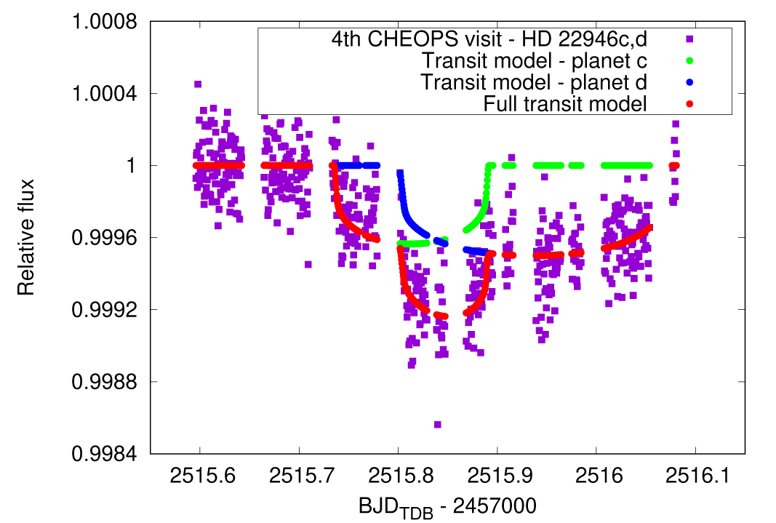
Figure 2. CHEOPS observations of the star HD 22946 on October 28, 2021. The observed light curve wad overplotted with the best fit model. Besides the summed model also the individual models of the planets c and d are displayed.

On 2021 February 12, two subsequent eruptions occurred above the western limb of the Sun, as seen along the Sun-Earth line. The first event was a typical slow coronal mass ejection (CME), followed ∼7 h later by a smaller and collimated prominence eruption, originating south of the CME, followed by a plasma blob. These events were observed not only by the SOHO and STEREO-A missions, but also by the suite of remote-sensing instruments on board Solar Orbiter [19]. It was shown how data acquired by the Full Sun Imager (FSI), the Metis coronagraph, and the Heliospheric Imager (HI) from the Solar Orbiter perspective can be combined to study the eruptions and different source regions. Images acquired by the two Metis channels in the visible light (VL) and H I Ly-α line (UV) were combined to derive physical information about the expanding plasma. The polarization ratio technique was also applied for the first time to Metis images acquired in the VL channel. The two eruptions were followed in 3D from their source region to their expansion in the intermediate corona. By combining VL and UV Metis data, the formation of a post-CME current sheet (CS) was followed for the first time in the intermediate corona. The plasma temperature gradient across a post-CME blob propagating along the CS was also measured for the first time.

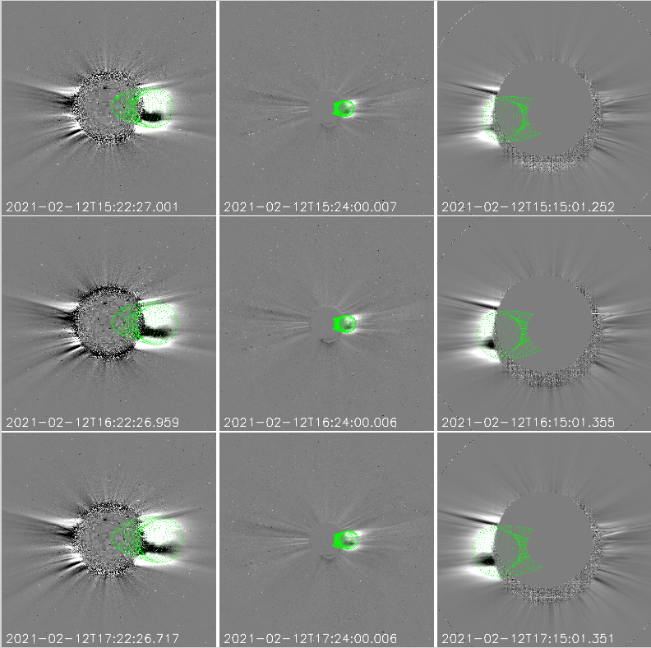

Figure 3. The February 12 CME as observed by coronagraphs on board different spacecraft at different times. Upper row: GCS reconstruction of the CME on February 12 observed by LASCO-C2 at 15:22–07:58 UT (left panel), by COR2-A at 15:24–08:24 UT (middle panel), and by Metis at 15:15–12:15 UT (right panel). Middle row: GCS reconstruction of the CME on February 12 observed by LASCO-C2 at 16:22–07:58 UT (left panel), by COR2-A at 16:24–08:24 UT (middle panel), and by Metis at 16:15–12:15 UT (right panel). Lower row: GCS reconstruction of the CME on February 12 observed by LASCO-C2 at 17:22–07:58 UT (left panel), by COR2-A at 17:24–08:24 UT (middle panel), and by Metis at 17:15–12:15 UT (right panel).

Water (H2O) ice is a ubiquitous component of the universe, having been detected in a variety of interstellar and Solar System environments where radiation plays an important role in its physico-chemical transformations. Although the radiation chemistry of H2O astrophysical ice analogues has been well studied, direct and systematic comparisons of different solid phases are scarce and are typically limited to just two phases. In the article [25] there are described the results of an in-depth study of the 2 keV electron irradiation of amorphous solid water (ASW), restrained amorphous ice (RAI) and the cubic (Ic) and hexagonal (Ih) crystalline phases at 20 K so as to further uncover any potential dependence of the radiation physics and chemistry on the solid phase of the ice. Mid-infrared spectroscopic analysis of the four investigated H2O ice phases revealed that electron irradiation of the RAI, Ic, and Ih phases resulted in their amorphization (with the latter undergoing the process more slowly) while ASW underwent compaction. The abundance of hydrogen peroxide (H2O2) produced as a result of the irradiation was also found to vary between phases, with yields being highest in irradiated ASW. This observation is the cumulative result of several factors including the increased porosity and quantity of lattice defects in ASW, as well as its less extensive hydrogen-bonding network. Our results have astrophysical implications, particularly with regards to H2O-rich icy interstellar and Solar System bodies exposed to both radiation fields and temperature gradients.

References

[1] SKOPAL, Augustín. The emergence of a neutral wind region in the orbital plane of symbiotic binaries during their outbursts. In The Astronomical Journal, 2023, vol. 165, no. 6, article no. 258, p. 1-19.

[2] GARAI, Zoltán - OSBORN, H. P. - GANDOLFI, Davide - BRANDEKER, A. - SOUSA, S. G. - LENDL, M. - BEKKELIEN, A. - BROEG, C. - COLLIER CAMERON, A. - EGGER, J. A. - HOOTON, M. J. - ALIBERT, Y. - DELREZ, L. - FOSSATI, L. - SALMON, S. - WILSON, T. G. - BONFANTI, A. - TUSON, A. - ULMER MOLL, S. - SERRANO, L. M. - BORSATO, Luca - ALONSO, Roi - ANGLADA, G. - ASQUIER, J. - BARRADO Y NAVASCUES, D. - BARROS, S. C. C. - BÁRCZY, T. - BAUMJOHANN, W. - BECK, M. - BECK, T. - BENZ, W. - BILLOT, N. - BIONDI, F. - BONFILS, X. - BUDER, M. - CABRERA, J. - CESSA, V. - CHARNOZ, S. - CSIZMADIA, S. - CUBILLOS, P. E. - DAVIES, M. B. - DELEUIL, M. - DEMANGEON, O. D. S. - DEMORY, B.-O. - EHRENREICH, D. - ERIKSON, A. - VAN EYLEN, V. - FORTIER, A. - FRIDLUND, M. - GILLON, M. - VAN GROOTEL, V. - GUEDEL, M. - GUENTHER, M. N. - HOYER, S. - ISAAK, K. G. - KISS, L. L. - KRISTIANSEN, M. H. - LASKAR, J. - LECAVELIER DES ETANGS, A. - LOVIS, Christophe - LUNTZER, A. - MAGRIN, D. - MAXTED, P. F. L. - MORDASINI, C. - NASCIMBENI, V. - OLOFSSON, G. - OTTENSAMER, Roland - PAGANO, Isabella - PALLÉ, Enric - PETER, G. - PIOTTO, G. - POLLACCO, Don - QUELOZ, D. - RAGAZZONI, R. - RANDO, N. - RAUER, H. - RIBAS, Ignasi - SANTOS, N. C. - SCANDARIATO, G. - SÉGRANSAN, D. - SIMON, A. E. - SMITH, A. M. S. - STELLER, M. - SZABÓ, Gy. M. - THOMAS, N. - UDRY, S. - VENTURINI, J. - WALTON, N. Refined parameters of the HD 22946 planetary system and the true orbital period of planet d. In Astronomy and Astrophysics, 2023, vol. 674, article no. A44, p. 1-14

[3] SHAGATOVA, Natalia - SKOPAL, Augustín - KUNDRA, Emil - KOMŽÍK, Richard - SHUGAROV, Sergey - PRIBULLA, Theodor - KRUSHEVSKA, Viktoriia. Density asymmetry and wind velocities in the orbital plane of the symbiotic binary EG Andromedae. In Astronomy and Astrophysics, 2023, vol. 676, article no. A98, p. 1-12.
[4] PRIBULLA, Theodor - BORKOVITS, Tamás - JAYARAMAN, Rahul - RAPPAPORT, Saul A. - MITNYAN, Tibor - ZASCHE, Petr - KOMŽÍK, Richard - ANDRÁS, Pál - UHLÁŘ, Robert - MAŠEK, Martin - HENZL, Zbyněk - BARNA BIRÓ, Imre - CSÁNYI, István - STUIK, Remko - KRISTIANSEN, Martti H. - SCHWENGELER, Hans M. - GAGLIANO, Robert - JACOBS, Thomas L. - OMOHUNDRO, Mark - KOSTOV, Veselin B. - POWELL, Brian P. - TERENTEV, Ivan A. - VANDERBURG, Andrew - LACOURSE, Daryll M. - RODRIGUEZ, Joseph E.- BAKOS, Gáspár CSUBRY, Zoltán - HARTMAN, Joel. BU Canis Minoris - the most compact known flat doubly eclipsing quadruple system. In Monthly Notices of the Royal Astronomical Society, 2023, vol. 524, no. 3, p. 4220-4238.

[5] RAPPAPORT, S. A. - BORKOVITS, T. - GAGLIANO, R. - JACOBS, Thomas L. - TOKOVININ, Andrei - MITNYAN, T. - KOMŽÍK, Richard - KOSTOV, V. B. - POWELL, B. P. - TORRES, Guillermo - TERENTEV, I. - OMOHUNDRO, M. - PRIBULLA, Theodor - VANDERBURG, Andrew - KRISTIANSEN, M. H. - LATHAM, Dave W. - SCHWENGELER, H. M. - LACOURSE, D. - BIRÓ, I. B. - CSÁNYI, I. - CZAVALINGA, D. - GARAI, Zoltán - PÁL, A. - RODRIGUEZ, J. E. - STEVENS, D. J. A study of nine compact triply eclipsing triples. In Monthly Notices of the Royal Astronomical Society, 2023, vol. 521, no. 1, p. 558-584.

[6] KARLICKÝ, Marian - RYBÁK, Ján. Multi-periodicity of high-frequency type III bursts as a signature of the fragmented magnetic reconnection. In Universe, 2023, vol. 9, no. 2, article no. 92, p. 1-12.

[7] MIFSUD, Duncan V. - HERCZKU, Péter - RAHUL, K. K. - RAMACHANDRAN, Ragav - SUNDARARAJAN, Pavithraa - KOVÁCS, Sándor T. S. - SULIK, Béla - JUHÁSZ, Zoltán - RÁCZ, Richárd - BIRI, Sándor - KAŇUCHOVÁ, Zuzana - MCCULLOUGH, Robert W. - SIVARAMAN, Bhalamurugan - IOPPOLO, Sergio - MASON, Nigel. A systematic mid-infrared spectroscopic study of thermally processed SO2 ices. In Physical Chemical Physics, 2023, vol. 25, p. 26278-26288.

[8] SKOPAL, Augustín. Multiwavelength modeling the SED of luminous supersoft X-ray sources in Large Magellanic cloud and Small Magellanic cloud. In The Astronomical Journal, 2022, vol. 164, no. 4, article no. 145, p. 1-18.

[9] BORKOVITS, T. - MITNYAN, T. - RAPPAPORT, S. A. - PRIBULLA, Theodor - POWELL, B. P. - KOSTOV, V. B. - BIRÓ, I. B. - CSÁNYI, I. - GARAI, Zoltán - GARY, B. L. - KAYE, T. G. - KOMŽÍK, Richard - TERENTEV, I. - OMOHUNDRO, M - GAGLIANO, R. - JACOBS, T. - KRISTIANSEN, M. H. - LACOURSE, D. - SCHWENGELER, H. M. - CZAVALINGA, D. - SELI, B. - HUANG, C. X. - PÁL, A. - VANDERBURG, Andrew - RODRIGUEZ, Eloy - STEVENS, D. J. Triply eclipsing triple stars in the northern TESS fields: TICs 193993801, 388459317, and 52041148. In Monthly Notices of the Royal Astronomical Society, 2022, vol. 510, no. 1, p. 1352-1374.

[10] BUDAJ, Ján - MALIUK, Andrii - HUBENY, Ivan. WD 1145+017: Alternative models of the atmosphere, dust clouds, and gas rings. In Astronomy and Astrophysics, 2022, vol. 660, article no. A72, p. 1-14.

[11] GARAI, Zoltán. Grazing, non-transiting disintegrating exoplanets observed with the planned Ariel space observatory. In Experimental Astronomy, 2022, vol. 53, no. 2, p. 729-748.

[12] GARAI, Zoltán - PRIBULLA, Theodor - KOVÁCS, J. - SZABÓ, Gy. M. - CLARET, Antonio - KOMŽÍK, Richard - KUNDRA, Emil. Rapidly rotating stars and their transiting planets: KELT-17b, KELT-19Ab, and KELT-21b in the
CHEOPS and TESS era. In Monthly Notices of the Royal Astronomical Society,
2022, vol. 513, no. 2, p. 2822-2840.

[13] MANNADAY, Vineet Kumar - THAKUR, Parijat - SOUTHWORTH, John - JIANG, Ing-Guey - SAHU, D.K. - MANCINI, Luigi - VAŇKO, Martin – KUNDRA, Emil - GAJDOŠ, Pavol - A-THANO, Napaporn - SARIYA, Devesh P. - YEH, Li-Chin - GRIV, Evgeny - MKRTICHIAN, David - SHLYAPNIKOV, Aleksey. Revisiting the transit timing variations in the TrES-3 and Qatar-1 systems with TESS data. In The Astronomical Journal, 2022, vol. 164, no. 5, article no. 198, p. 1-20

[14] POWELL, Brian P. - RAPPAPORT, Saul A. - BORKOVITS, Tamás – KOSTOV, Veselin B. - TORRES, Guillermo - JAYARAMAN, Rahul - LATHAM, Dave W. - KUČÁKOVÁ, Hana - GARAI, Zoltán - PRIBULLA, Theodor – VANDERBURG, Andrew - KRUSE, Ethan - BARCLAY, Thomas -OLMSCHENK, Greg - KRISTIANSEN, Martti H. K. - GAGLIANO, Robert - JACOBS, Thomas L. - LACOURSE, Daryll M. - OMOHUNDRO, Mark - SCHWENGELER, Hans M. - TERENTEV, Ivan A. - SCHMITT, Alan R. TIC 114936199: A quadruple star system with a 12 day outer-orbit eclipse. In The Astrophysical Journal, 2022, vol. 938, no. 2, article no. 133, p. 1-15.

[15] RAPPAPORT, S. A. - BORKOVITS, T. - GAGLIANO, R. - JACOBS, Thomas L. - KOSTOV, V. B. - POWELL, B. P. - TERENTEV, I. - OMOHUNDRO, M. - TORRES, Guillermo - VANDERBURG, Andrew - MITNYAN, T. - KRISTIANSEN, M. H. - LACOURSE, D. - SCHWENGELER, H. M. - KAYE, T. G. - PÁL, A. - PRIBULLA, Theodor - BIRÓ, I. B. - CSÁNYI, I. - GARAI, Zoltán - ZASCHE, Petr - MAXTED, P. F. L. - RODRIGUEZ, J. E. - STEVENS, D. J. Six new compact triply eclipsing triples found with TESS. In Monthly Notices of the Royal Astronomical Society, 2022, vol. 513, no. 3, p. 4341-4360.

[16] SZABÓ, Gyula M. - GARAI, Zoltán - BRANDEKER, A. et al., Transit timing variations of AU Microscopii b and c. In Astronomy and Astrophysics, 2022, vol. 659, article no. L7, p. 1-9.

[17] SZABÓ, Gyula M. - KÁLMÁN, Szilárd - PRIBULLA, Theodor – CLARET, Antonio - MUGNAI, Lorenzo V. - PASCALE, Enzo - WALTHAM, Dave - BORSATO, Luca - GARAI, Zoltán - SZABÓ, Róbert. High-precision photometry with Ariel. In Experimental Astronomy, 2022, vol. 53, no. 2, p. 607-634.

[18] VAŇKO, Martin - PRIBULLA, Theodor - GAJDOŠ, Pavol - BUDAJ, Ján - ZVERKO, Juraj - PAUNZEN, Ernst - GARAI, Zoltán - HAMBÁLEK, Ľubomír - KOMŽÍK, Richard - KUNDRA, Emil. HD 183986: A high-contrast SB2 system with a pulsating component. In The Astronomical Journal, 2022, vol. 163, no. 6, article no. 245, p. 1-14.

[19] BEMPORAD, A. - ANDRETTA, Vincenzo - SUSINO, R. - MANCUSO, S. - SPADARO, D. - MIERLA, M. - BERGHMANS, D. - D’ HUYS, E. - ZHUKOV, A. N. - TALPEANU, D.-C. - COLANINNO, R. - HESS, P. - KOZA, Július – JEJČIČ, Sonja - HEINZEL, Petr - ANTONUCCI, E. - DA DEPPO, V. - FINESCHI, Silvano - FRASSATI, F. - JERSE, G. - LANDINI, F. - NALETTO, G. - NICOLINI, G. - PANCRAZZI, M. - ROMOLI, Marco - SASSO, C. - SLEMER, A. - STANGALINI, M. - TERIACA, L. Coronal mass ejection followed by a prominence eruption and a plasma blob as observed by Solar Orbiter. In Astronomy and Astrophysics, 2022, vol. 665, article no. A7, p. 1-15.

[20] BERRIOS SAAVEDRA, Gerardine - UTZ, Dominik - VARGAS DOMINGUEZ, Santiago - CAMPOS ROZO, Jose Ivan - GONZÁLEZ MANRIQUE, Sergio Javier - GÖMÖRY, Peter - KUCKEIN, Christoph - BALTHASAR, Horst - ZELINA, Peter. Observational evidence for two-component distributions describing solar magnetic bright points. In Astronomy and Astrophysics, 2022, vol. 657, article no. A79, p. 12.

[21] GUNÁR, Stanislav - HEINZEL, Petr - KOZA, Július - SCHWARTZ, Pavol. Large impact of the Mg II h and k incident radiation change on results of radiative transfer models and the importance of dynamics. In The Astrophysical Journal, 2022, vol. 934, no. 2, article no. 133, p. 1-7.

[22] KOZA, Július - GUNÁR, Stanislav - SCHWARTZ, Pavol - HEINZEL, Petr - LIU, Wenjuan. Data-driven model of temporal evolution of solar Mg II h and k profiles over the solar cycle. In The Astrophysical Journal Supplement Series, 2022, vol. 261, no. 2, article no. 17, p. 1-18.

[23] VASHALOMIDZE, Z. - ZAQARASHVILI, Teimuraz V. - KUKHIANIDZE, V. - RAMISHVILI, G. - HANSLMEIER, Arnold - GÖMÖRY, Peter. Prominence instability and CMEs triggered by massive coronal rain in the solar atmosphere. In Astronomy and Astrophysics, 2022, vol. 658, article no. A18, p. 1-10.

[24] MIFSUD, Duncan V. - HERCZKU, Péter - RÁCZ, Richárd - RAHUL, K. K. - KOVÁCS, Sándor T. S. - JUHÁSZ, Zoltán - SULIK, Béla - BIRI, Sándor - MCCULLOUGH, Robert W. - KAŇUCHOVÁ, Zuzana - IOPPOLO, Sergio - HAILEY, Perry A. - MASON, Nigel. Energetic electron irradiations of amorphous and crystalline sulphur-bearing astrochemical ices. In Frontiers in Chemistry, 2022, vol. 10, article no. 1003163, p. 1-12.

[25] MIFSUD, Duncan V. - HAILEY, Perry A. - HERCZKU, Péter – JUHÁSZ, Zoltán - KOVÁCS, Sándor T. S. - SULIK, Béla - IOPPOLO, Sergio – KAŇUCHOVÁ, Zuzana - MCCULLOUGH, Robert W. - PARIPÁS, Béla - MASON, Nigel. Laboratory experiments on the radiation astrochemistry of water ice phases. In European Physical Journal D, 2022, vol. 76, no. 5, article no. 87, p. 1-15

[26] MIFSUD, Duncan V. - KAŇUCHOVÁ, Zuzana - IOPPOLO, Sergio - HERCZKU, Péter - TRASPAS MUIŇA, Alejandra - FIELD, T. A. - HAILEY, Perry A. - JUHÁSZ, Zoltán - KOVÁCS, Sándor T. S. - MASON, Nigel - MCCULLOUGH, Robert W. - PAVITHRAA, S. - RAHUL, K. K. - PARIPÁS, Béla - SULIK, Béla - CHOU, S.-L. - LO, J.-I. - DAS, Ankan - CHENG, B.-M. - RAJASEKHAR, B. N. - BHARDWAJ, A. - SIVARAMAN, Bhalamurugan. Mid-IR and VUV spectroscopic characterisation of thermally processed and electron irradiated CO_2 astrophysical ice analogues. In Journal of Molecular Spectroscopy, 2022, vol. 385, article no. 111599, p. 1-12.

[27] MIFSUD, Duncan V. - HAILEY, Perry A. - HERCZKU, Péter - SULIK, Béla - JUHÁSZ, Zoltán - KOVÁCS, Sándor T. S. - KAŇUCHOVÁ, Zuzana – IOPPOLO, Sergio - MCCULLOUGH, Robert W. - PARIPÁS, Béla - MASON, Nigel. Comparative electron irradiations of amorphous and crystalline astrophysical ice analogues. In Physical Chemistry Chemical Physics, 2022, vol. 24, no. 18, p. 10974-10984.

[28] MIFSUD, Duncan V. - KAŇUCHOVÁ, Zuzana - IOPPOLO, Sergio - HERCZKU, Péter - TRASPAS MUIŇA, Alejandra - SULIK, Béla - RAHUL, K. K. - KOVÁCS, Sándor T. S. - HAILEY, Perry A. - MCCULLOUGH, Robert W. - MASON, Nigel - JUHÁSZ, Zoltán. Ozone production in electron irradiated CO_2: O_2 ices. In Physical Chemistry Chemical Physics, 2022, vol. 24, no. 30, p. 18169-18178.

[29] MIGLIORINI, A. - KAŇUCHOVÁ, Zuzana - IOPPOLO, Sergio - BARBIERI, M. - JONES, N. C. - HOFFMANN, S. V. - STRAZZULLA, Giovanni - TOSI, F. - PICCIONI, Giuseppe. On the origin of molecular oxygen on the surface of Ganymede. In Icarus, 2022, vol. 383, article no. 115074, p. 1-11.2

[30] NESLUŠAN, Luboš - TOMKO, Dušan. The impact hazard of near-Sun comets. In Monthly Notices of the Royal Astronomical Society, 2022, vol. 512, no. 3, p. 3414-3421.

