The activities of the Astronomical Institute of the Slovak Academy of Sciences (AISAS), Tatranská Lomnica (www.astro.sk), related to COSPAR, were devoted to research in stellar, solar, and interplanetary physics using different satellite observations, mainly in the UV, XUV and X-ray spectral regions. Stellar data of the Swift, XMM-Newton, MOST, TESS, CHEOPS, and Kepler satellites, including the HST were used for research of various variable stars and start hosting exoplanets [1,3,12]. Data of the current SDO, IRIS, STEREO, ACE, Hinode, Wind, SORCE/SOLSTICE and other satellites were used for solar research. In common, these data were used with the simultaneously acquired data by the ground-based solar telescopes [2,4,5,6,8,11]. Topic of the interstellar particles has been also addressed [7,9,10]. Hereby we present some examples of the results obtained by the AISAS staff.
We used observations carried out with The Neil Gehrels Swift Observatory (Swift) to explore the outburst on the white dwarf surface in newly doscovered symbiotic binary HBHA 1704-05 in the constellation of Sagittae that suddenly brightened at the beginning of August 2018 [12]. Using the X-Ray Telescope on the board of the Swift satellite allowed us to measure the increase of the X-ray counts within the 0.3-10 keV band, whereas its UltraViolet-Optical Telescope (UVOT) recorded significant brightening within its ultraviolet filters UVW2 (λ = 1928 Å), UVM2 (λ = 2246 Å), and UVW1 (λ = 2600 Å). On the basis on the UVOT observations, supplemented by simultaneous optical measurements, we reconstructed and modeled the spectral energy distribution (SED) during the outburst of HBHA 1704-05 (now called as V426 Sagittae). Example of the SED is shown in Figure 1. Our analysis revealed that V426 Sge experienced the so-called Z And-type outburst of a symbiotic binary that is caused by an abrupt increase of the mass-accretion rate onto the white dwarf. V426 Sagittae (HBHA 1704-05) became a classical symbiotic star.
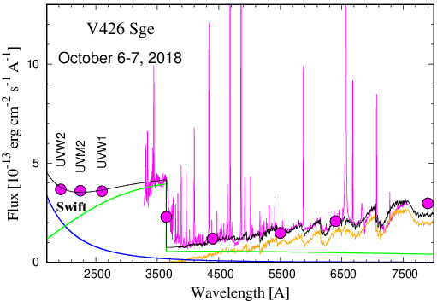

Figure 1. Example of the observed (in magenta) and modeled (black line) SEDs of V426 Sge during its 2018 outburst. The blue, green and orange lines denote components of radiation from the nuclear-burning white dwarf, ionized material ejected during the explosion and giant, respectively. Circles (from left to right) represent Swift-UVOT fluxes and the optical flux-points given by the multicolor UBVRI photometry.
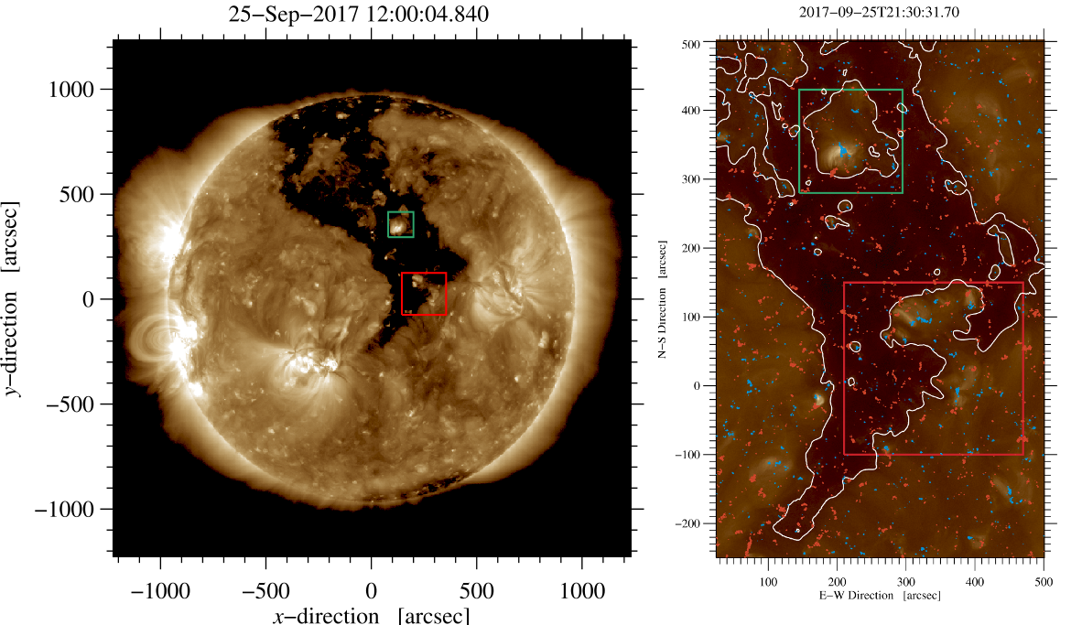
A joint multi-instrument campaign involving a suite of space-borne and ground-based observatories was carried out in 2017 September 20 - 30 aimed, besides other targets, at coronal holes [11]. Out of leading ground-based telescopes (GREGOR, Vacuum Tower Telescope, ChroTel), the following spacecraft contributed to the coronal hole study: Solar Dynamics Observatory, Hinode, Advanced Composition Explorer, and Wind. The study was focused at a very extended non-polar coronal hole (Figure 2). On 2017 September 24, the coronal hole developed patches of flux emergence, which contributed to the decrease of its overall area. These flux emergence patches erode the coronal hole and transform the area into a more quiet-Sun-like area. Conversely, flux cancellation leads to the reduction of opposite-polarity magnetic fields and to an increase in the area of the coronal hole. Other global coronal hole characteristics, including the evolution of the associated magnetic flux and the aforementioned area evolution in the EUV, are studied using data of the Helioseismic and Magnetic Imager and Atmospheric Imaging Assembly onboard the Solar Dynamics Observatory. The interplanetary medium parameters of the solar wind, measured in site by the Advanced Composition Explorer and Wind spacecraft, display values compatible with the presence of the coronal hole. Furthermore, a particular transient is found in those parameters.

Figure 2. Left: AIA EUV 193 Å images of non-polar coronal hole on 25 September 2017. The green and red boxes refer to regions of interest studied in detail. The coronal hole boundary is outlined by white contours (right). Positive and negative polarities derived from HMI magnetograms are displayed in red and blue, respectively.

We derived high-precision reference profiles of the Mg ii h and k lines that represent the quiet Sun during a minimum of the solar activity [4]. To do so, we used the broad catalog of full-Sun mosaics obtained by the Interface Region Imaging Spectrograph (IRIS). To minimize the influence of the local variations due to the on-disk solar features and to achieve low levels of uncertainties, we used 12 IRIS full-Sun mosaics without sunspots or other significant signs of solar activity (Figure 3, left panel). These mosaics were obtained between 2019 April and 2020 September in the near-ultraviolet spectral range. In this study, we present the disk-averaged reference profiles of Mg ii h and Mg ii k lines, together with a series of reference profiles spanning the distance between the disk center and the solar limb. These series of profiles offer a detailed representation of the center-to-limb variation of both Mg ii h and Mg ii k lines. The reference Mg ii h and k line profiles provided in this study can be used as the incident radiation boundary condition for radiative-transfer modeling of prominences, spicules, and other coronal and chromospheric structures.

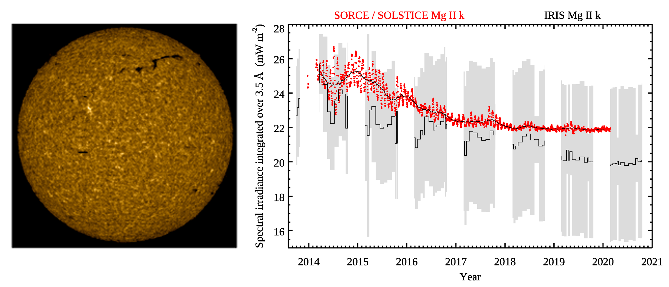
Figure 3: Left: the IRIS full-Sun mosaic obtained in the Mg II k line center on 2019 May 27, i.e., before the end of the solar cycle 24 on 2019 December. Right: spectral irradiances integrated over the interval of 3.5 Å in the Mg II k line observed by the SORCE/SOLSTICE (red dots overlaid with the black curve) and IRIS (black histogram-like curve). The gray areas indicate the uncertainties of IRIS measurements.

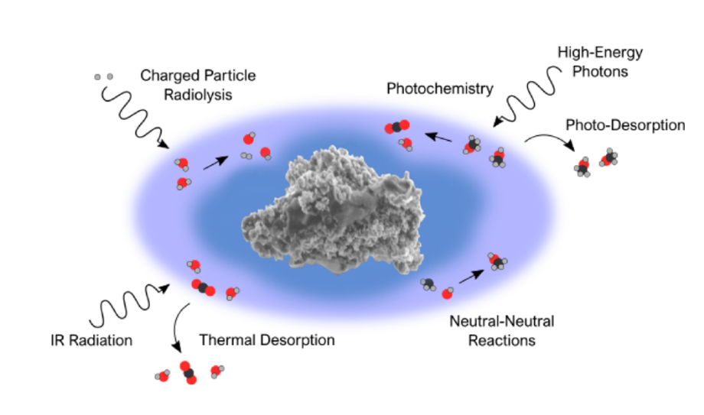
Among the many avenues of research currently being explored is the laboratory processing of astrophysical ice analogues. Such research involves the synthesis of an ice of specific morphology and chemical composition at temperatures and pressures relevant to a selected astrophysical setting - such as the interstellar medium, the surfaces of icy moons, or cometary nuclei. The in-situ changes in ice morphology and chemistry occurring during such processing (see Figure 4) are often monitored via spectroscopic or spectrometric techniques.
In the work [7] we present a new high-vacuum laboratory end station: The Ice Chamber for Astrophysics–Astrochemistry (ICA) located at the Institute for Nuclear Research (Atomki) in Debrecen, Hungary. The ICA has been specifically designed for the study of the physico-chemical properties of astrophysical ice analogues and their chemical evolution when subjected to ionizing radiation and thermal processing. Ices pre-prepared in the ICA may be processed in a variety of ways. A 2 MV Tandetron accelerator is capable of delivering a wide variety of high-energy ions into the ICA, which simulates ice processing by cosmic rays, solar wind, or magnetospheric ions. The ICA is also equipped with an electron gun that may be used for electron impact radiolysis of ices. Thermal processing (20-300K) of both deposited and processed ices may be monitored by means of both FTIR spectroscopy and quadrupole mass spectrometry. A detailed description of the ICA setup as well as an overview of the preliminary results obtained and future plans is presented in the paper [7]. In the paper [9], we are focusing on characterising of the electron beams used for electron impact studies, as well as reporting the preliminary results obtained during electron irradiation and thermal processing of selected ices.

Fig 4: Illustrative summary of the chemical processes that may occur in the icy mantles of interstellar dust grains.

Sulfur is the tenth most abundant element in the universe and is known to play a significant role in biological systems. Accordingly, in recent years there has been increased interest in the role of sulfur in astrochemical reactions and planetary geology and geochemistry. In the paper [10], we have reviewed the results of laboratory investigations concerned with sulfur chemistry in several astrophysical ice analogues. Potential future studies in the field of solid phase sulfur astrochemistry are also discussed in the context of forthcoming space missions, such as the NASA James Webb Space Telescope and the ESA Jupiter Icy Moons Explorer mission.

Besides of this, the AISAS staff was involved (or leading) in the last two years in 3 coordinated observing campaigns supporting individual Parker Solar Probe encounters to the Sun by the ground-based observations of the AISAS owned CoMP-S instrument at the Lomnicky Stit Observatory.

References:

[1] BORSATO, L. - PIOTTO, G. - GANDOLFI, Davide - NASCIMBENI, V. - LACEDELLI, G. - MARZARI, F. - BILLOT, N. - MAXTED, Pierre - SOUSA, S. - CAMERON, A. C. - BONFANTI, A. - WILSON, T. G. - SERRANO, L. M. - GARAI, Zoltán - ALIBERT, Y. - ALONSO, Roi - ASQUIER, J. - BÁRCZY, T. - BANDY, T. - BARRADO, D. - BARROS, S. C. C. - BAUMJOHANN, W. - BECK, M. - BECK, T. - BENZ, W. - BONFILS, X. - BRANDEKER, A. - BROEG, C. - CABRERA, J. - CHARNOZ, S. - CSIZMADIA, S. - DAVIES, M. B. - DELEUIL, M. - DELREZ, L. - DEMANGEON, O. - DEMORY, B.-O. - DES ETANGS, A. L. - EHRENREICH, D. - ERIKSON, A. - ESCUDÉ, G. A. - FORTIER, A. - FOSSATI, L. - FRIDLUND, M. - GILLON, M. - GUEDEL, M. - HASIBA, J. - HENG, K. - HOYER, S. - ISAAK, Kate - KISS, L. L. - KOPP, E. - LASKAR, J. - LENDL, M. - LOVIS, Christophe - MAGRIN, D. - MUNARI, M. - OLOFSSON, G. - OTTENSAMER, Roland - PAGANO, Isabella - PALLÉ, Enric - PETER, G. - POLLACCO, Don - QUELOZ, D. - RAGAZZONI, R. - RANDO, N. - RAUER, H. - RIBAS, Ignasi - SÉGRANSAN, D. - SANTOS, N. - SCANDARIATO, G. - SIMON, Andrei - SMITH, A. M. S. - STELLER, M. - SZABO, Gyula M. - THOMAS, N. - UDRY, S. - VAN GROOTEL, V. - WALTON, N. Exploiting timing capabilities of the CHEOPS mission with warm-Jupiter planets. In Monthly Notices of the Royal Astronomical Society, 2021, vol. 506, no. 3, p. 3810-3830.

[2] DUDÍK, Jaroslav - DEL ZANNA, Giulio - RYBÁK, Ján - LORINČÍK, Juraj - DZIFČÁKOVÁ, Elena - MASON, Helen E. - TOMCZYK, Steve - GALLOY, Michael. Electron densities in the solar corona measured simultaneously in the extreme ultraviolet and infrared. In The Astrophysical Journal, 2021, vol. 906, no. 2, article no. 118, p. 1-16

[3] GARAI, Zoltán - PRIBULLA, Theodor - PARVIAINEN, H. - PALLÉ, Enric - CLARET, A. - SZIGETI, L. - BÉJAR, V. J. S. - CASASAYAS-BARRIS, N. - CROUZET, N. - FUKUI, Akihiko - CHEN, G. - KAWAUCHI, K. - KLAGYIVIK, P. - KURITA, S. - KUSAKABE, N. - DE LEON, J. - LIVINGSTON, J. - LUQUE, R. - MORI, M. - MURGAS, F. - NARITA, N. - NISHIUMI, T. - OSHAGH, M. - SZABÓ, Gy. M. - TAMURA, M. - TERADA, Y. - WATANABE, N. Is the orbit of the exoplanet WASP-43b really decaying? TESS and MuSCAT2 observations confirm no detection. In Monthly Notices of the Royal Astronomical Society, 2021, vol. 508, no. 4, p. 5514-5523.

[4] GUNÁR, Stanislav - KOZA, Július - SCHWARTZ, Pavol - HEINZEL, Petr – LIU, Wenjuan. Quiet-Sun Mg II h and k line profiles derived from IRIS full-Sun mosaics. I. Reference profiles and center-to-limb variation. In The Astrophysical Journal Supplement Series, 2021, vol. 255 no. 1, article no. 16, p. 1-20.
[5] GUNÁR, Stanislav - SCHWARTZ, Pavol - KOZA, Július - HEINZEL, Petr. Quiet-Sun hydrogen Lyman-alpha line profile derived from SOHO/SUMER solar-disk observations. In Astronomy and Astrophysics, 2020, vol. 644, article no. A109, p. 1-16.
[6] HEINZEL, Petr - SCHWARTZ, Pavol - LORINČÍK, Juraj - KOZA, Július – JEJČIČ, Sonja - KURIDZE, D. Signatures of helium continuum in cool flare loops observed by SDO/AIA. In The Astrophysical Journal Letters, 2020, vol. 896, no. 2, article no. L35, p. 1-7.

[7] HERCZKU, Péter - MIFSUD, Duncan V.** - IOPPOLO, Sergio - JUHÁSZ, Zoltán - KAŇUCHOVÁ, Zuzana - KOVÁCS, Sándor T. S. - TRASPAS MUIŇA, Alejandra - HAILEY, Perry A. - RAJTA, István - VAJDA, István - MASON, Nigel - MCCULLOUGH, Robert W. - PARIPÁS, Béla - SULIK, Béla. The Ice Chamber for Astrophysics-Astrochemistry (ICA): A new experimental facility for ion impact studies of astrophysical ice analogs. In Review of Scientific Instruments, 2021, vol. 92, no. 8, article no. 084501, p. 1-12.

[8] KURIDZE, D. - MATHIOUDAKIS, M. - HEINZEL, Petr - KOZA, Július - MORGAN, Huw - OLIVER, R. - KOWALSKI, Adam F. - ALLRED, Joel C. Spectral characteristics and formation height of off-limb flare ribbons. In The Astrophysical Journal, 2020, vol. 896, no. 2, article no. 120, p. 1-14.

[9] MIFSUD, Duncan V. - JUHÁSZ, Zoltán** - HERCZKU, Péter - KOVÁCS, Sándor T. S. - IOPPOLO, Sergio - KAŇUCHOVÁ, Zuzana - CZENTYE, Máté - HAILEY, Perry A. - TRASPAS MUIŇA, Alejandra - MASON, Nigel - MCCULLOUGH, Robert W. - PARIPÁS, Béla - SULIK, Béla. Electron irradiation and thermal chemistry studies of interstellar and planetary ice analogues at the ICA astrochemistry facility. In European Physical Journal D, 2021, vol. 75, no. 6, article no. 182, p. 1-9.

[10] MIFSUD, Duncan V. - KAŇUCHOVÁ, Zuzana - HERCZKU, Péter - IOPPOLO, Sergio - JUHÁSZ, Zoltán - KOVÁCS, Sándor T. S. - MASON, Nigel - MCCULLOUGH, Robert W. - SULIK, Béla. Sulfur ice astrochemistry: A review of laboratory studies. In Space Science Reviews, 2021, vol. 217, no. 1, article no. 14, p. 1-34.

[11] PALACIOS, Judith - UTZ, Dominik - HOFMEISTER, Stefan – KRIKOVA, Kilian - GÖMÖRY, Peter - KUCKEIN, Christoph - DENKER, Carsten – VERMA, Meetu - GONZÁLEZ MANRIQUE, Sergio Javier - CAMPOS ROZO, Jose Ivan - KOZA, Július - TEMMER, Manuela - VERONIG, Astrid - DIERCKE, Andrea - KONTOGIANNIS, Ioannis - CID, Consuelo. Magnetic flux emergence in a coronal hole. In Solar Physics, 2020, vol. 295, article no. 64, p. 1-23.

[12] SKOPAL, Augustín - SHUGAROV, Sergey - MUNARI, Ulisse - MASETTI, N. - MARCHESINI, E. - KOMŽÍK, Richard - KUNDRA, Emil - SHAGATOVA, Natalia - TARASOVA, Taissiia Natasha - BUIL, Christian - BOUSSIN, C. - SHENAVRIN, Viktor, I. - HAMBSCH, Franz-Josef - DALLAPORTA, Sergio - FRIGO, Andrea - GARDE, Olivier - ZUBAREVA, Alexandra M. - DUBOVSKÝ, Pavol - KROLL, Peter. The path to Z And-type outbursts: The case of V426 Sagittae (HBHA 1704-05). In Astronomy and Astrophysics, 2020, vol. 636, article no. A77, p. 1-18. (2019

