The activities of the Astronomical Institute of the Slovak Academy of Sciences (AISAS), Tatranská Lomnica (http://www.astro.sk), related to COSPAR, were devoted to the research in solar and stellar physics using different satellite observations, mainly in the UV, XUV and X-ray spectral regions. Mainly data of the current SOHO mission, the TRACE and the RHESSI satellites and previous satellites of the NOAA and GOES series were used for solar research. Some other studies were focused on the solar activity, solar coronal emission and the cosmic rays with respect to the solar cycle and its influence on the heliosphere using the ground-based data. Stellar data of the IUE satellite and the HST were used for research of various variable stars.
New results on dynamics and energy transfer in the outer layers of the solar atmosphere were presented in papers devoted to quiet solar network and dynamic fibrils with help of data acquired in frame of the SOHO/TRACE joint operation program JOP078 using CDS, MDI, EIT instruments on-board SOHO as well as the TRACE satellite. In particular, mutual relations of the upper layers of the quiet solar atmosphere in/above chromospheric network were studied (Fig.2) in order to identify physical mechanisms which control energy transfer to the corona [4,5]. Dynamics of fibrils was investigated statistically to confirm/regret the theoretically proposed mechanisms causing highly dynamic nature of the solar chromosphere. Data were acquired thanks to EU 6thFP funds of the OPTICON Trans-national Access Program [6].
The space-time distribution of the solar corona brightness was investigated over more than five solar cycles using the data sets compiled and the institute. A pronounced north/south asymmetry of the solar corona was studied including the quasi-biennial oscillations and rotation of the solar corona [2,3,13].
By analyzing a time-latitudinal evolution of the intensities of the green corona in the period of 1939-2006 we found out that the splitting of their poleward-migrating branch at middle-latitudes and its disappearance around the poles can be used to forecast the minima and maxima of solar activity. We showed, for the first time, that the localization of the intensities of the green corona in this high-latitude branch of the corona is intricately related with the migration of magnetic fields from middle latitudes towards the poles, which is also traced by large prominences [8].
After comparing the coronal index with similar indices of solar activity like the Wolf number, radio flux 10.7m (2800 MHz), MgII index and Total Solar Irradiance (TSI) one, we found that the coronal index is completely on par with all the other indices, correlating with TSI even better in some phases of a cycle [9,10]. Periodicities of the Total Solar Irradiance (TSI) as well as other solar indices was investigated [1].
An analysis of the eclipse observations from 2005 and 2006 has revealed that the inner part of this corona is structurally almost identical with the X-ray and EUV coronas, which means that these two layers of the corona can be used to model the former. This is a very important fact in light of our recent findings, employing a qualitatively new method of data processing, that the hyper-fine structure of the white-light corona differs much from what we thought of it so far [11].
Ground-based radio data and the UV imaging of the solar corona, obtained by the space-born instruments, were analyzed together in order to reveal mechanisms causing the solar radio burst with the long emission periods [7].
A new extremely extended solar activity index covering independently from the northern and the southern atmospheres of the Sun was prepared and published [13,14]. It consists of the daily and monthly data of the hemispheric relative sunspot numbers. Data of two observatories – Kanzelhoehe Solar Observatory (Austria) and Skalnate Pleso Observatory (Slovakia) were used reaching the 84% data coverage over the whole time epoch between 1945 and 2004. The data set is now the best possible tool to investigate the N-S asymmetry of the solar magnetic flux over the epoch of the last 5 solar cycles (Fig.1) [14,15].
The far ultraviolet spectroscopy taken by the FUSE satellite (Far Ultraviolet Spectroscopic Explorer) was used to study the outburst stage of the symbiotic prototype Z And during its major 2000-03 outburst. The UV spectra, complemented with other ground-based observations, revealed an expansion of the hot object and an enhanced mass loss from the system (Fig. 3). Evolution of the two-temperature type of the spectrum at the initial stages of the outburst suggested that the active object consisted of optically thick, slowly expanding disk-like structured material encompassing the white dwarf at the orbital plane and of a fast optically thin wind escaping the star at higher latitudes. A striking similarity between [FeVII] 608.7 nm and the Raman scattered OVI 103.2 nm line profiles at/after the dilution of the disk suggested their origin within the interaction zone, where the winds from both stars collide. This can help to study streaming along the zone of interaction between the two winds [12].
In the period Jun 28 – July 12, 2006 the new run of the SOHO joint observing program JOP 171 (SOHO, TRACE, RHESSI) was operated by the ground-based observations of the Dutch Open Telescope and the Kanzelhoehe and Hvar Solar Observatories. Details are given at the dedicated web page of the campaign http://www.astro.sk/~choc/open/06_dot/06_dot.html. The first results have been already presented at different conferences on the topic of the onset of the flare/CME events. New SOHO joint observing program JOP 189 for instruments on-board the SOHO, thew HINODE, the TRACE and the RHESSI satellites was performed (August 3-31, 2007) supported by the ground-based observing campaign of the Dutch Open Telescope and the Kanzelhoehe and Hvar Solar Observatories (http://www.astro.sk/~choc/open/07_dot/07_dot.html). The best data of these campaign will be utilized in the near future. Additionally, a special observing program was prepared and run in frame of the first SOHO-HINODE observing campaign in April 2007 upon invitation of the campaign leader Dr. W. Curdt (MPS, Lindau, Germany).
The Astronomical Institute organised in cooperation with the US-SK Joint Research Project on Space Weather led by prof. S.T. Wu (CSPAR, UAH, Huntsville, AL, USA) a closed (upon invitation) workshop on the topic of the solar flares and their relation to initialisation of the coronal mass ejections (Tatranska Lomnica, 13-15 Sept, 2006). Colleagues working in this branch of solar physics from the Central Europe region (Austria, Croatia, Czech republic, Hungary, Poland) and Slovakia (Bratislava, Rimavska Sobota, and Tatranska Lomnica) have taken part at the workshop. Oral presentations of almost all participants about their research and latest achievements in the field of solar flares and CMEs.
References.
- ATAÇ, T. – ÖZGÜÇ, A. – RYBÁK, J. Periodicities in irradiance and in other solar activity indices during cycle 23. In: Solar Physics Vol. 237 (2006), p. 433–444.
- BADALYAN, O.G. – OBRIDKO, V.N. – SÝKORA, J. Cyclic variations in the differential rotation of the solar corona. In: Astronomy Reports Vol. 50 (2006), no.4, p.312–324.
- BADALYAN, O.G. – BLUDOVA, N.G. – SÝKORA, J. Comparisons of the green-line corona brightness with the magnetic field strenght and the summary sunspot area. In: Contributions of the Astronomical Observatory Skalnaté Pleso Vol. 37, no. 2, (2007), p.125-141.
- GÖMÖRY, P. – RYBÁK, J. – KUČERA, A. – CURDT, W. – WÖHL, H. Propagating wawes in the chromospheric network. In: Coimbra Solar Physics Meeting. The Physics of Chromospheric Plasmas. - San Francisco: Astronomical Society of Pacific, 2007. ISBN 978-1-583812-36-5. Vol. 368, p. 133-136.
- GÖMÖRY, P. – RYBÁK, J. – KUČERA, A. – CURDT, W. – WÖHL, H. SOHO/CDS observations of waves above the network. In: Astronomy and Astrophysics Vol. 448 (2006), p. 1169–1175.
- KOZA, J. – SÜTTERLIN, P. – KUČERA, A. – RYBÁK, J . Temporal variations in fibril orientation. In: Coimbra Solar Physics Meeting - The Physics of Chromospheric Plasmas. - San Francisco: Astronomical Society of Pacific, 2007. Vol. 368, p. 115-118.
- MESZÁROSOVÁ, H. – KARLICKÝ, M. – RYBÁK, J. – FÁRNÍK, F. – JIŘIČKA, K. Long period variations of dm-radio and X-ray fluxes in three X-class flares. In: Astronomy and Astrophysics Vol. 460, (2006), p. 865-874.
- MINAROVJECH, M. Time-latitude prominences distribution (1967-2006). In: Contributions of the Astronomical Observatory Skalnaté Pleso Vol. 37, no. 3, (2007), p. 184-188.
- MINAROVJECH, M. – RUŠIN, V. – SANIGA, M. Total solar irradiance and the FeXIV corona. In: Solar Physics Vol. 241, (2007), p. 269-278.
- MINAROVJECH, M. – RUŠIN, V. – SANIGA, M. Time-latitudinal dynamics of magnetic fields and the green corona over three solar cycles. In: Solar Physics Vol. 241, (2007), p. 263-268.
- PASACHOFF, J.M. – RUŠIN, V. – DRUCKMÜLLER, M. – SANIGA, M. Fine structures in the white-light solar corona at the 2006 eclipse. In: The Astrophysical Journal. Vol. 665, (2007), p. 824-829.
- SKOPAL, A. - VITTONE, A.A. - ERRICO, L. - OTSUKA, M. - TAMURA,S. - WOLF, M. - ELKIN, V.G. Structure of the hot object in the symbiotic prototype Z Andromedae during its 2003-03 active phase. In: Astronomy and Astrophysics. Vol. 453, p. 279-293.
- STORINI, M. – HOFER, M.Y. – SÝKORA, J. Towards the understanding of coronal hole occurrence during the Schwabe cycle. In: Advances in Space Research Vol. 38 (2006), 912–920.
- TEMMER, M. – RYBÁK, J. – BENDÍK, P. – VERONIG, A. – VOGLER, F. – OTRUBA, W. – PÖTZI, W. – HANSLMEIER, A. Hemispheric sunspot numbers Rn and Rs from 1945–2004: catalogue and N–S asymmetry analysis for solar cycles 18–23. In: Astronomy and Astrophysics Vol. 447 (2006), p.735–743.
- TEMMER, M. – RYBÁK, J. – BENDÍK, P. – VERONIG, A. – VOGLER, F. – PÖTZI, A. – OTRUBA, W. – HANSLMEIER, A. Hemispheric sunspot numbers 1945–2004: data merging from two observatories. In: Central European Astrophysical Bulletin Vol. 30 (2006), no. 1, p. 65–73.

Figures:
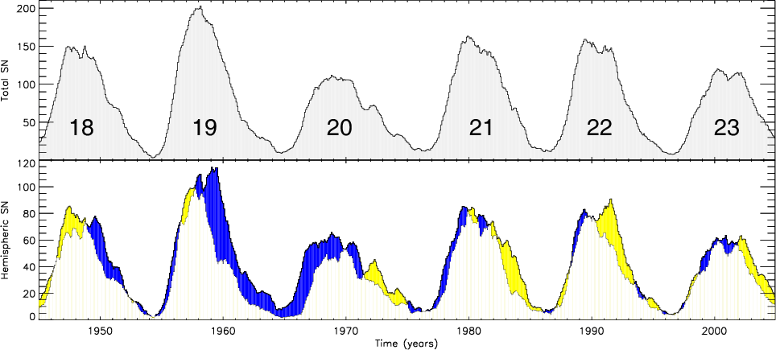
Fig. 1. Smoothed monthly relative sunspot numbers for the entire disk (upper panel) and excesses of one hemisphere over the other (bottom panel) based on smoothed-monthly hemispheric sunspot number. Excess of the southern/northern hemisphere is shaded yellow/blue. The time span covers the years from 1945 until 2004 which corresponds to solar cycles 18−23.
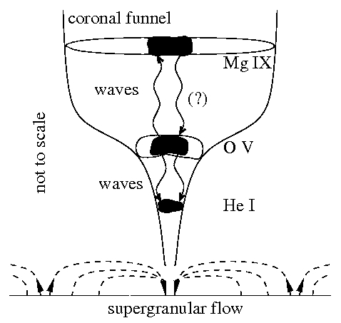
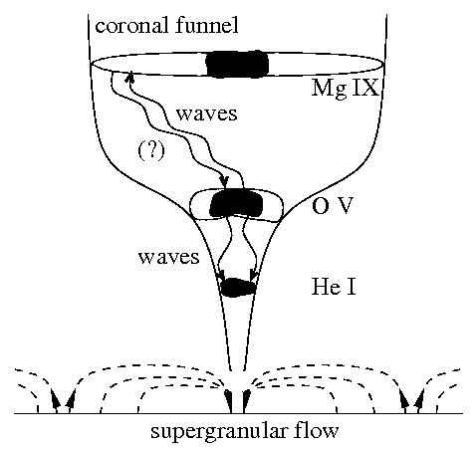
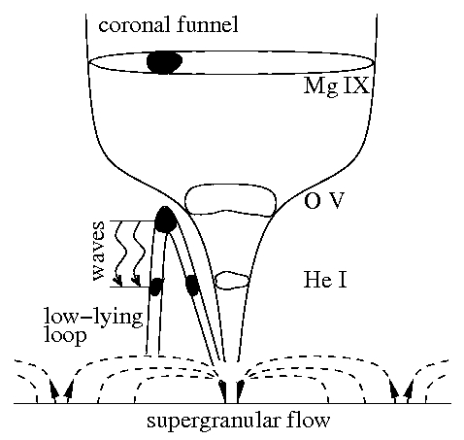

Fig. 2. Sketches of the different possible scenarios of the dynamics and energy transport between the corona and the undelying layers/structures of the solar atmosphere in/above the network. Our observational findings do not conflict with predictions derived for the reconnection (nanoflare) heating mechanism of the outer solar atmosphere although the original source of the energy release was impossible to recognized.

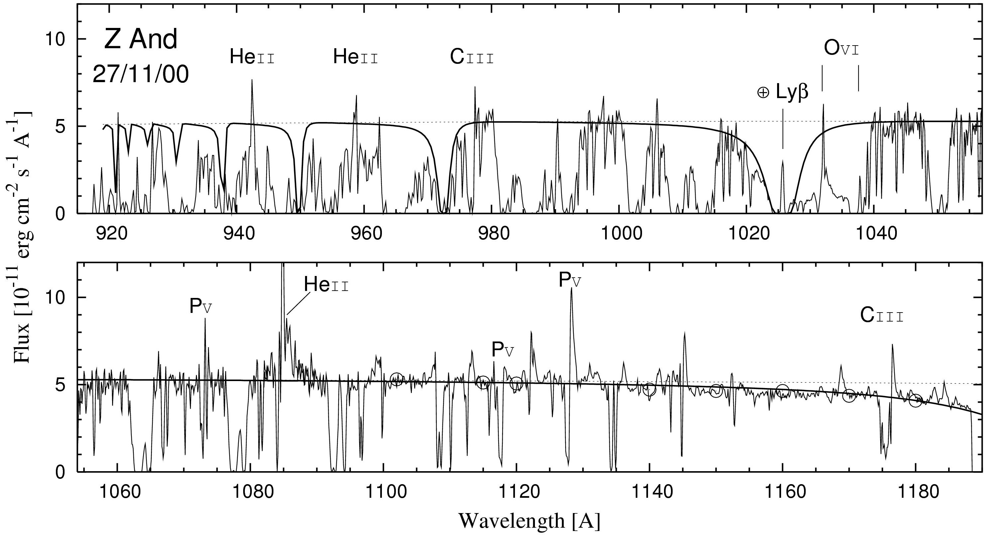
Fig. 3. Dereddened FUSE spectra of Z And from the maximum of the optical brightness. The solid line represents the Rayleigh attenuated (N_H = 7E+21 cm-2) blackbody radiation from the hot stellar source at 28000 K, while the dotted line is not attenuated. Most of the absorption features are due to H_2 in the interstellar medium. The P-Cygni type of profiles for C III and P V lines and the broad emission in the He II 1084 A profile indicate the mass outflow from the star.

