The activities of the Astronomical Institute of the Slovak Academy of Sciences (AISAS), Tatranská Lomnica (www.astro.sk), related to COSPAR, were devoted to research in stellar and solar physics using different satellite observations, mainly in the UV, XUV and X-ray spectral regions. Stellar data of the IUE, Kepler satellites, and the HST were used for research of various variable stars and start hosting exoplanets [1-5]. Data of the current SOHO mission, Hinode, SDO, STEREO, GOES, Fermi, IRIS, and RHESSI satellites were used for solar research mostly focused on solar prominences and flares. In common, these data were used with the simultaneously acquired data by the ground-based solar telescopes [6-14]. Hereby we present an example of the results obtained by the AISAS staff, information on an education activity of the AISAS, and information on the WAMIS proposal cooperation [15].
Researchers from AISAS analysed the observation of KIC8462852 obtained by the Kepler satellite [5]. These observations show mysterious eclipse like events. It was even proposed that they might have been caused by aliens. We explored the possibility that such eclipses are caused by the dust clouds associated with massive parent bodies orbiting the host star. We assumed a massive object and a simple model of the dust cloud surrounding the object. Then, we used the numerical integration to simulate the evolution of the cloud, its parent body, and resulting light-curves as they orbit and transit the star. We found that it is possible to reproduce the basic features in the light-curve of KIC 8462852 with four objects enshrouded in dust clouds (Figure 1). With such physical models at hand, at present, there is no need to invoke alien mega-structures for an explanation of these light-curves.
Observations carried out with the space observatories, the Far Ultraviolet Spectroscopic Explorer (FUSE) and Hubble Space Telescope (HST), were used to model the spectral energy distribution of the symbiotic nova AG Pegasi [4]. In this way we demonstrated a high luminosity of the hot component of around 2200 solar units during the quiescent phase (Figure 2). This implies that the hydrogen-rich material nuclearly burns at the surface of a low-mass white dwarf (WD) in AG Peg. This luminosity requires accretion rate of a few times 10⁻⁸ solar masses per year. To increase the luminosity of the burning WD by a factor of ~10, to values observed around the maximum of the new 2015 outburst, a transient increase of the accretion rate to ~3.10⁻⁷ solar masses per year is needed. This accretion rate, however, exceeds the stable-burning limit, which leads to blowing optically thick wind from the WD. As a result the enhanced wind is ionised by the hot WD's pseudophotosphere, and thus converts a fraction of its stellar radiation to the nebular emission. The corresponding increase of the nebular emission then causes a relevant brightening in the light curve which we indicate as the outburst.
The study by Koza et al. [12] has been focused on the analysis of a quiescent solar prominence observed in the spectral line He I 5876 Å D3 on 2 August 2014 by the solar telescope THEMIS, located at Observatorio de Teide (Tenerife, Canary Islands). This study employs a context imagery of this prominence obtained by the cosmic solar observatories SDO and STEREO B in the EUV spectral regions. Figure 3 shows the prominence in the spectral regions around 304 Å, 211 Å, and 195 Å and selected intensity levels corresponding to the ground-based observations in the Hα (red contour) and He I 5876 Å D3 (yellow contours) spectral lines. Combination of such data allows to derive more detailed results on the followed solar activity features. In the case of this study, since the separation angle of the STEREO B spacecraft with Earth is 162 degrees, the SECCHI/EUVI 304 Å and 195 Å images of the prominence in the bottom panels of Figure 3 provide almost rear views of its dark central pillar and arcades stretching to the right, resembling its AIA 304 Å counterpart in the top left panel.
The Astronomical Institute organised in the year 2017 the lecture course – Radiative Transfer in Solar and Stellar Atmospheres - given for the undergraduate and PhD students from Slovakia by prof. Petr Heinzel of the Astronomincal Institute of Czech Acamedy od Sciences (Ondřejov, Czech republic) on May 29 - June 2, 2017 at AISAS at Tatranska Lomnica. This course of lectures was an intensive one-week course in the theory of radiative transfer in stellar atmospheres and related numerical methods. More details about the course of lectures can be found at the dedicated web page – https://www.ta3.sk/~koza/school2017.
In the years 2016-2017 AISAS has become involved in the proposal which has been submitted twice for consideration of an award by NASA (NASA H-TIDeS LCAS program). The proposal called “Waves and Magnetism in the Solar Atmosphere (WAMIS)” is led by Yuan-Kuen Ko (Naval Research Lab, Washington, USA) (PI), and its AISAS part by J. Rybak (Co-I). The team has received a negative agency decision due to NASA budget limitations although the proposal has been ranked high. The project is a long duration balloon based 20cm aperture coronagraph designed to obtain continuous measurements of the strength and direction of coronal magnetic fields within a large field-of-view over at least weeks at the spatial and temporal resolutions required to address several outstanding problems in coronal physics [15]. The WAMIS investigation, comprising a balloon-borne infra-red coronagraph and polarimeter to observe Fe XIII forbidden transitions and the He I line, should enable breakthrough science and enhance the value of data collected by other observatories on the ground (e.g. ATST, FASR, SOLIS, COSMO) and in space (e.g. Hinode, STEREO, SDO, SOHO and IRIS), and will advance technology for a future orbital missions.
Besides of this, the AISAS staff was involved (or leading) in the last two years in several coordinated observing campaigns focused on observations of several aspects of the solar activity. The integral part of the campaigns were also measurements performed by the space-born instruments on different satellites, e.g. IRIS, EIS/Hinode. The measurements were coordinated with the ground-based instruments including the AISAS owned CoMP-S and SCD instruments at the Lomnicky Peak Observatory.
References:

[1] SHAGATOVA, Natalia - SKOPAL, Augustín - CARIKOVÁ, Zuzana. Wind mass transfer in S-type symbiotic binaries : II. Indication of wind focusing. In Astronomy and Astrophysics, 2016, vol. 588, article no. A83, p. 1-10.

[2] GAJDOŠ, Pavol - PARIMUCHA, Štefan - HAMBÁLEK, Ľubomír - VAŇKO, Martin. Transit-timing variations in the system Kepler-410Ab. In Monthly Notices of the Royal Astronomical Society, 2017, vol. 469, p. 2907-2912.

[3] SHAGATOVA, Natalia - SKOPAL, Augustín. Wind asymmetry imprint in the UV light curves of the symbiotic binary SY Mus. In Astronomy and Astrophysics, 2017, vol. 602, article no. A71, p. 1-9.

[4] SKOPAL, Augustín - SHUGAROV, Sergey Yu. - SEKERÁŠ, Matej - WOLF, Marek - TARASOVA, Taissiia Natasha - TEYSSIER, Francois - FUJII, Mitsugu - GUARRO, Joan - GARDE, Olivier - GRAHAM, Keith - LESTER, Tim - BOUTTARD, V. - LEMOULT, Thierry - SOLLECCHIA, U. - MONTIER, Jacques - BOYD, David. New outburst of the symbiotic nova AG Pegasi after 165 yr. In Astronomy and Astrophysics, 2017, vol. 604, article no. A48, p. 1-19.

[5] NESLUŠAN, Luboš - BUDAJ, Ján. Mysterious eclipses in the light curve of KIC8462852: a possible explanation. In Astronomy and Astrophysics, 2017, vol. 600, article no. A86, p. 1-20.

[6] GÖMÖRY, Peter - VERONIG, Astrid - SU, Yang - TEMMER, Manuela - THALMANN, J.K. Chromospheric evaporation flows and density changes deduced from Hinode/EIS during an M1.6 flare. In Astronomy and Astrophysics, 2016, vol. 588, article no. A6, p. 1-12

[7] MÉSZÁROSOVÁ, Hana - RYBÁK, Ján - KASHAPOVA, Larisa K. - GÖMÖRY, Peter - TOKHCHUKOVA, S. - MYSHYAKOV, I. Broadband microwave sub-second pulsations in an expanding coronal loop of the 2011 August 10 flare. In Astronomy and Astrophysics, 2016, vol. 593, article no. A80, p. 1-11.

[8] UTZ, Dominik - MULLER, Richard - THONHOFER, S. - VERONIG, Astrid - HANSLMEIER, Arnold - BODNÁROVÁ, Marcela - BÁRTA, Miroslav - DEL TORO INIESTA, J.C. Long-term trends of magnetic bright points : I. Number of magnetic bright points at disc centre. In Astronomy and Astrophysics, 2016, vol. 585, article no. A39, p. 1-10.

[9] GÖMÖRY, Peter - BALTHASAR, Horst - KUCKEIN, Christoph - KOZA, Július - VERONIG, Astrid - GONZÁLEZ MANRIQUE, Sergio Javier - KUČERA, Aleš - SCHWARTZ, Pavol - HANSLMEIER, Arnold. Flare-induced changes of the photospheric magnetic field in a delta-spot deduced from ground-based observations. In Astronomy and Astrophysics, 2017, vol. 602, article no. A60, p. 1-8.

[10] HERNANDEZ-PEREZ, Aaron - THALMANN, J.K. - VERONIG, Astrid - SU, Yang - GÖMÖRY, Peter - DICKSON, Ewan C. Generation mechanisms of quasi-parallel and quasi-circular flare ribbons in a confined flare. In The Astrophysical Journal, 2017, vol. 847, no. 2, article no. 124, p. 1-14.

[11] KARLICKÝ, Marian - RYBÁK, Ján - MONSTEIN, Christian. Oscillations in the 45 - 5000 MHz radio spectrum of the 18 April 2014 flare. In Solar Physics, 2017, vol. 292, no. 7, article no. 94, p. 1-15. (2.682 - IF2016).

[12] KOZA, Július - RYBÁK, Ján - GÖMÖRY, Peter - KOZÁK, Matúš - LOPEZ ARISTE, Arturo. Spectral characteristics of the He I D3 line in a quiescent prominence observed by THEMIS. In Solar Physics, 2017, vol. 292, article no. 98, p. 1-23.

[13] KUCKEIN, Christoph - DIERCKE, A. - GONZÁLEZ MANRIQUE, Sergio Javier - VERMA, Meetu - LÖHNER-BÖTTCHER, J. - SOCAS-NAVARRO, H. - BALTHASAR, Horst - SOBOTKA, M. - DENKER, Carsten. Ca II 8542 angstrom brightenings induced by a solar microflare. In Astronomy and Astrophysics, 2017, vol. 608, article no. A117, p. 1-13.

[14] KURIDZE, D. - HENRIQUES, V. - MATHIOUDAKIS, M. - KOZA, Július - ZAQARASHVILI, T. V. - RYBÁK, Ján - HANSLMEIER, Arnold - KEENAN, Francis P. Spectroscopic inversions of the Ca II 8542 Angstrom line in a C-class solar flare. In The Astrophysical Journal, 2017, vol. 846, no. 1, article no. 9, p. 1-9.

[15] KO, Yuan-Kuen - MOSES, John D. - LAMING, John M. - STRACHAN, Leonard - BELTRAN, Samuel Tun - TOMCZYK, Steve - GIBSON, Sarah E. - AUCHERE, Frederic - CASINI, Roberto - FINESCHI, Silvano - KNOELKER, Michael - KORENDYKE, Clarence - MCINTOSH, Scott W. - ROMOLI, Marco - RYBÁK, Ján - SOCKER, Dennis G. - VOURLIDAS, Angelos - WU, Qian. Waves and Magnetism in the Solar Atmosphere (WAMIS). In Frontiers in Astronomy and Space Sciences : Stellar and Solar Physics, 2016, vol. 3, article no. 1, p. 1-13.

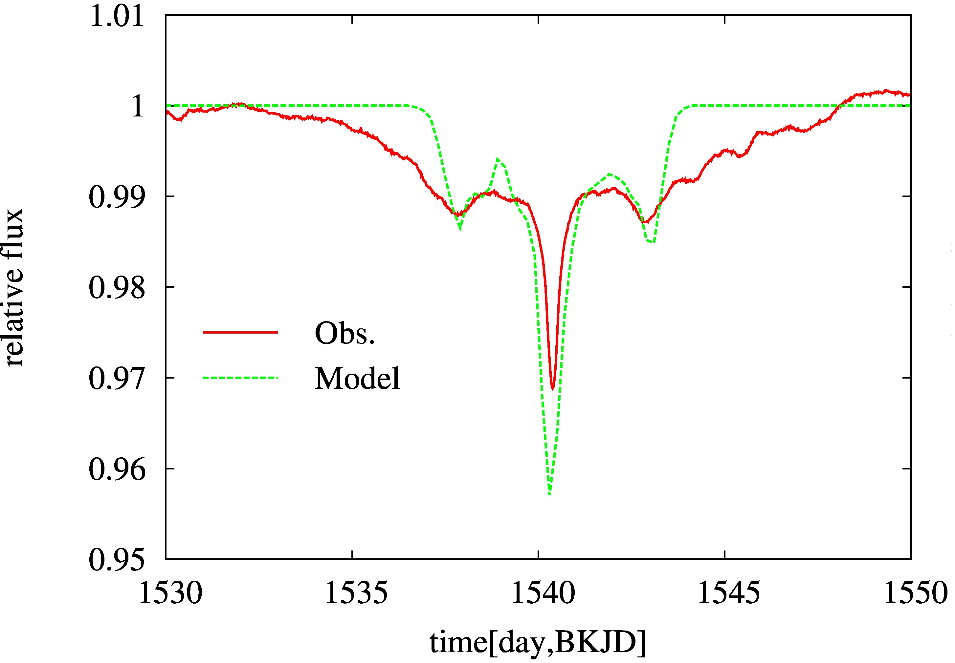
Figure 1. An example of a main eclipse event in the light-curve of KIC8462 observed with Kepler analyzed in this study [3] and comparison with the model. The fits may not be perfect but the main morphological features are represented.
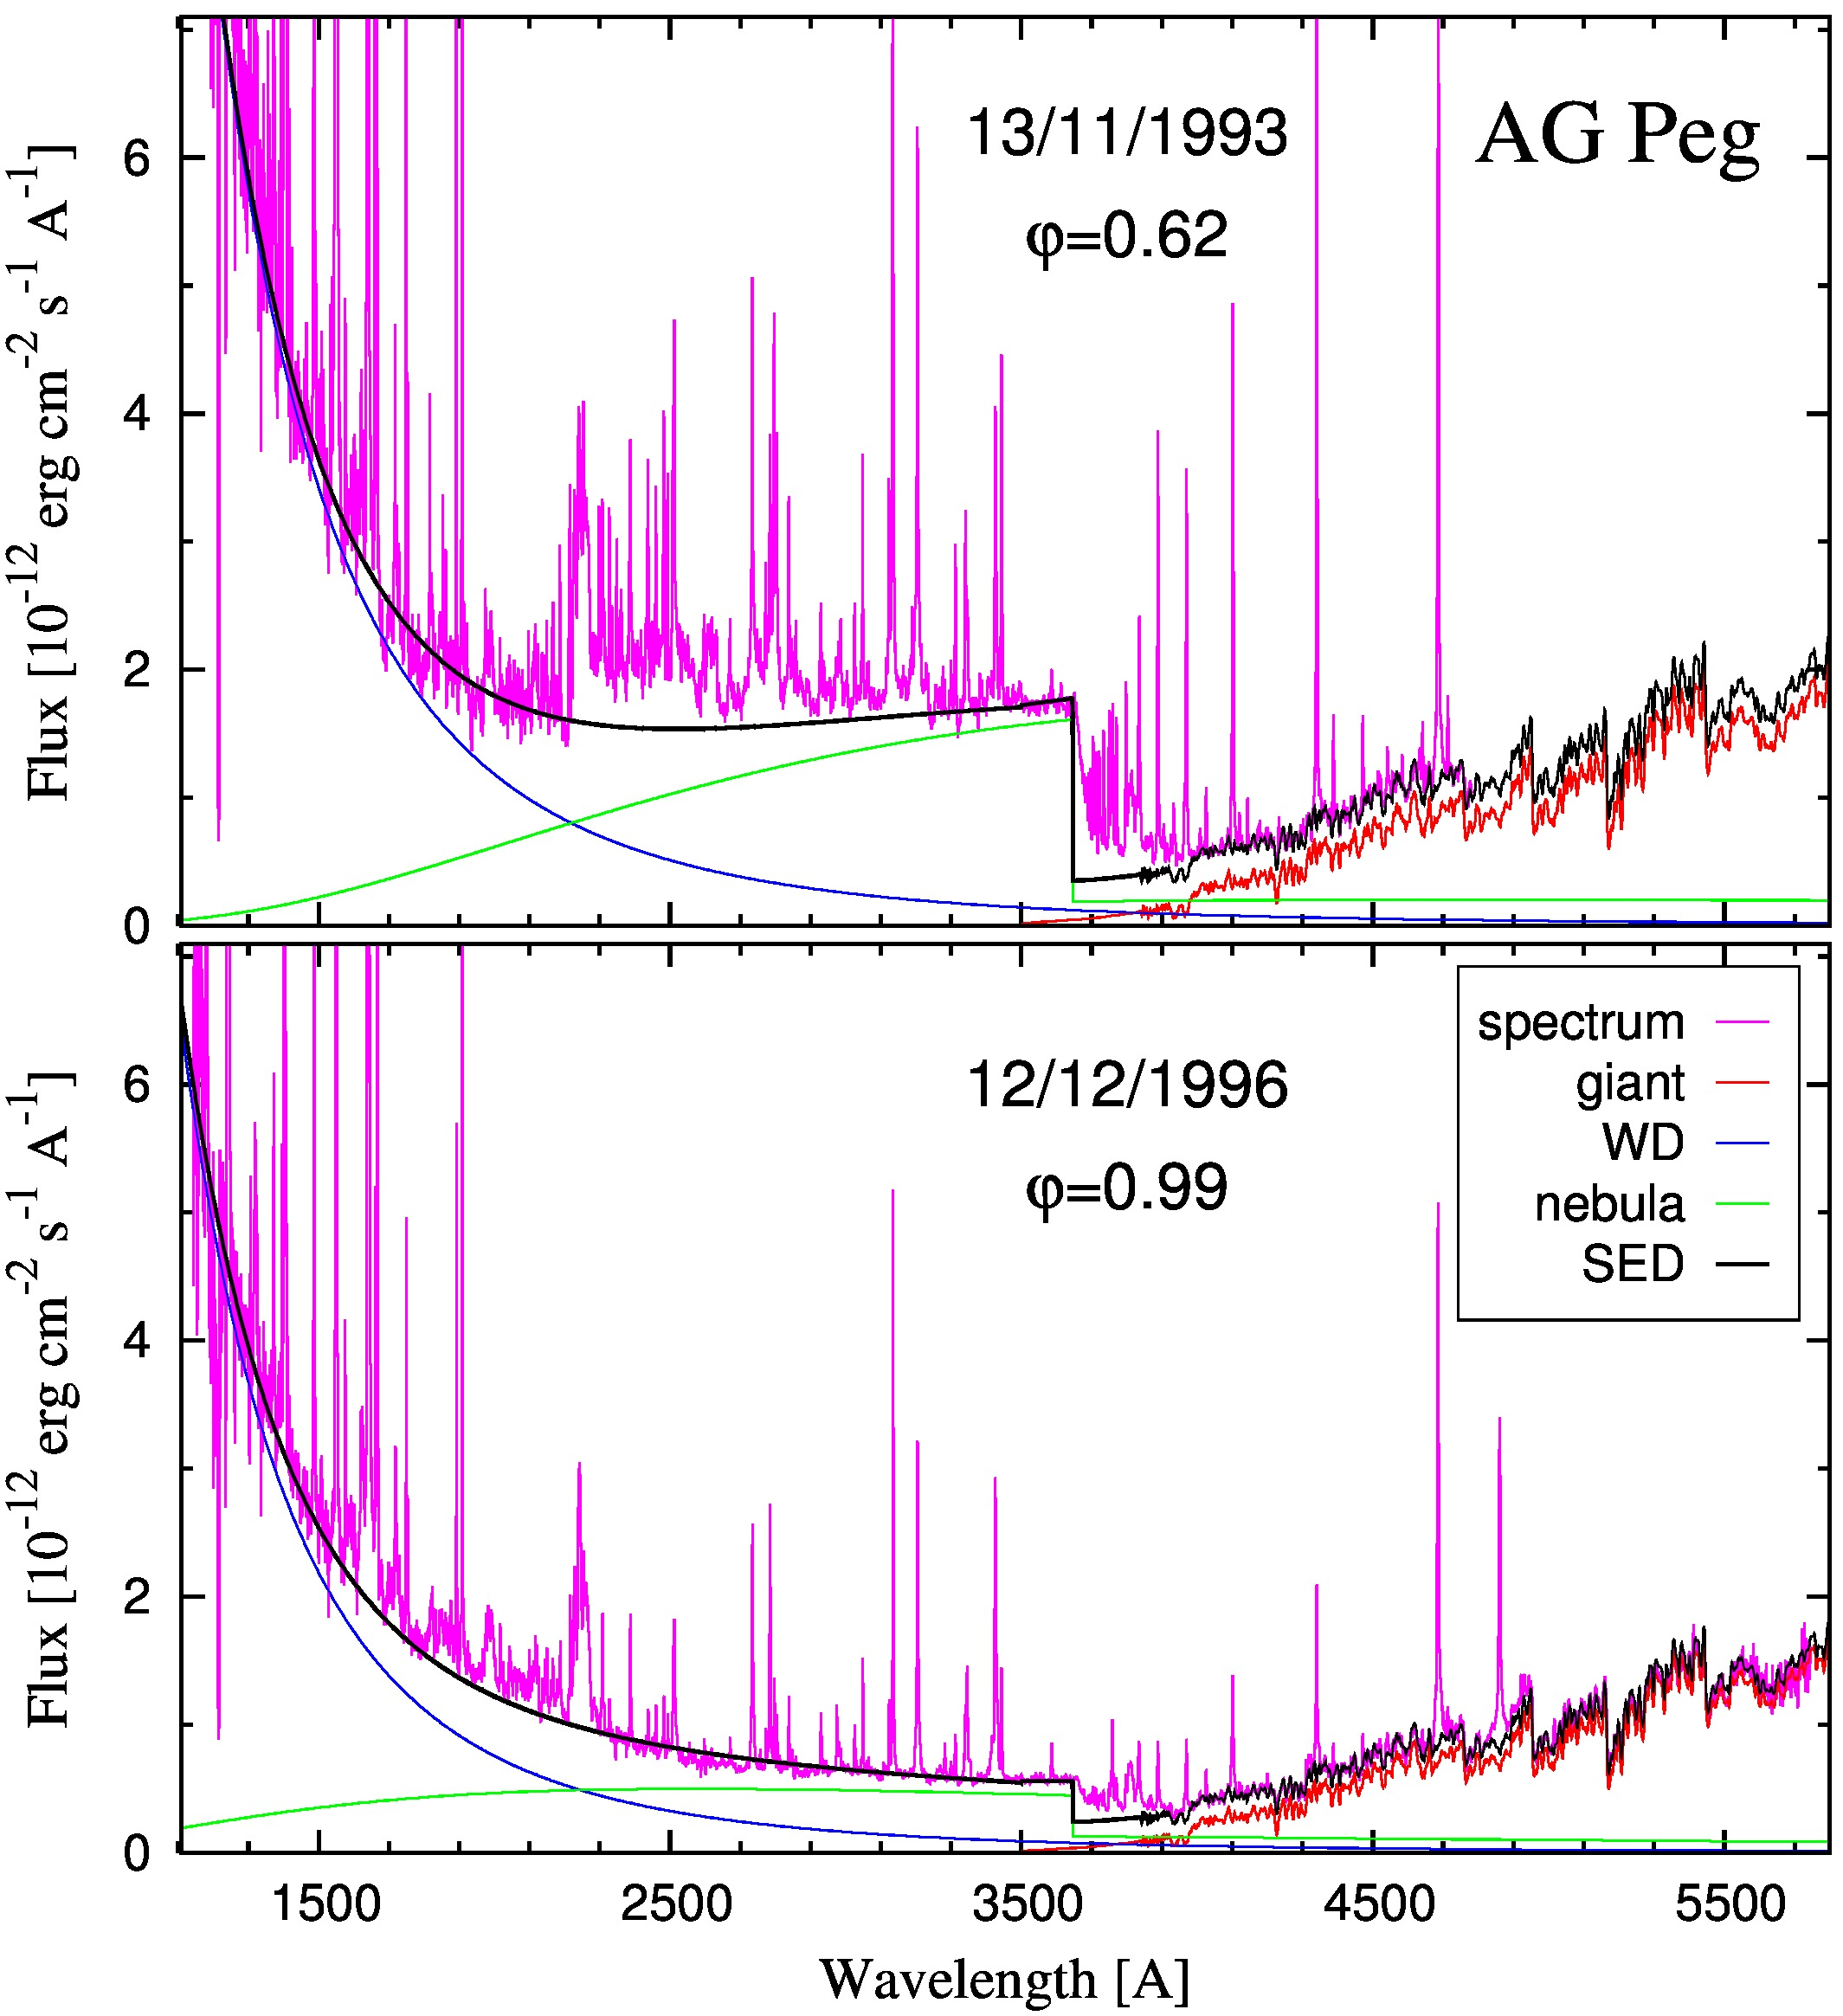
Figure 2. Ultraviolet/optical spectral energy distribution of AG~Peg during quiescent phase from two opposite orbital phases. Observations are represented by the HST spectra (magenta line). The model (black line) consists of the hydrogen nebular continuum (green line), the hot stellar source radiating at ~160 000 K (blue line) and the red giant spectrum (orange line). It corresponds to a high luminosity of the nuclearly-burning WD of around 2200 solar units.
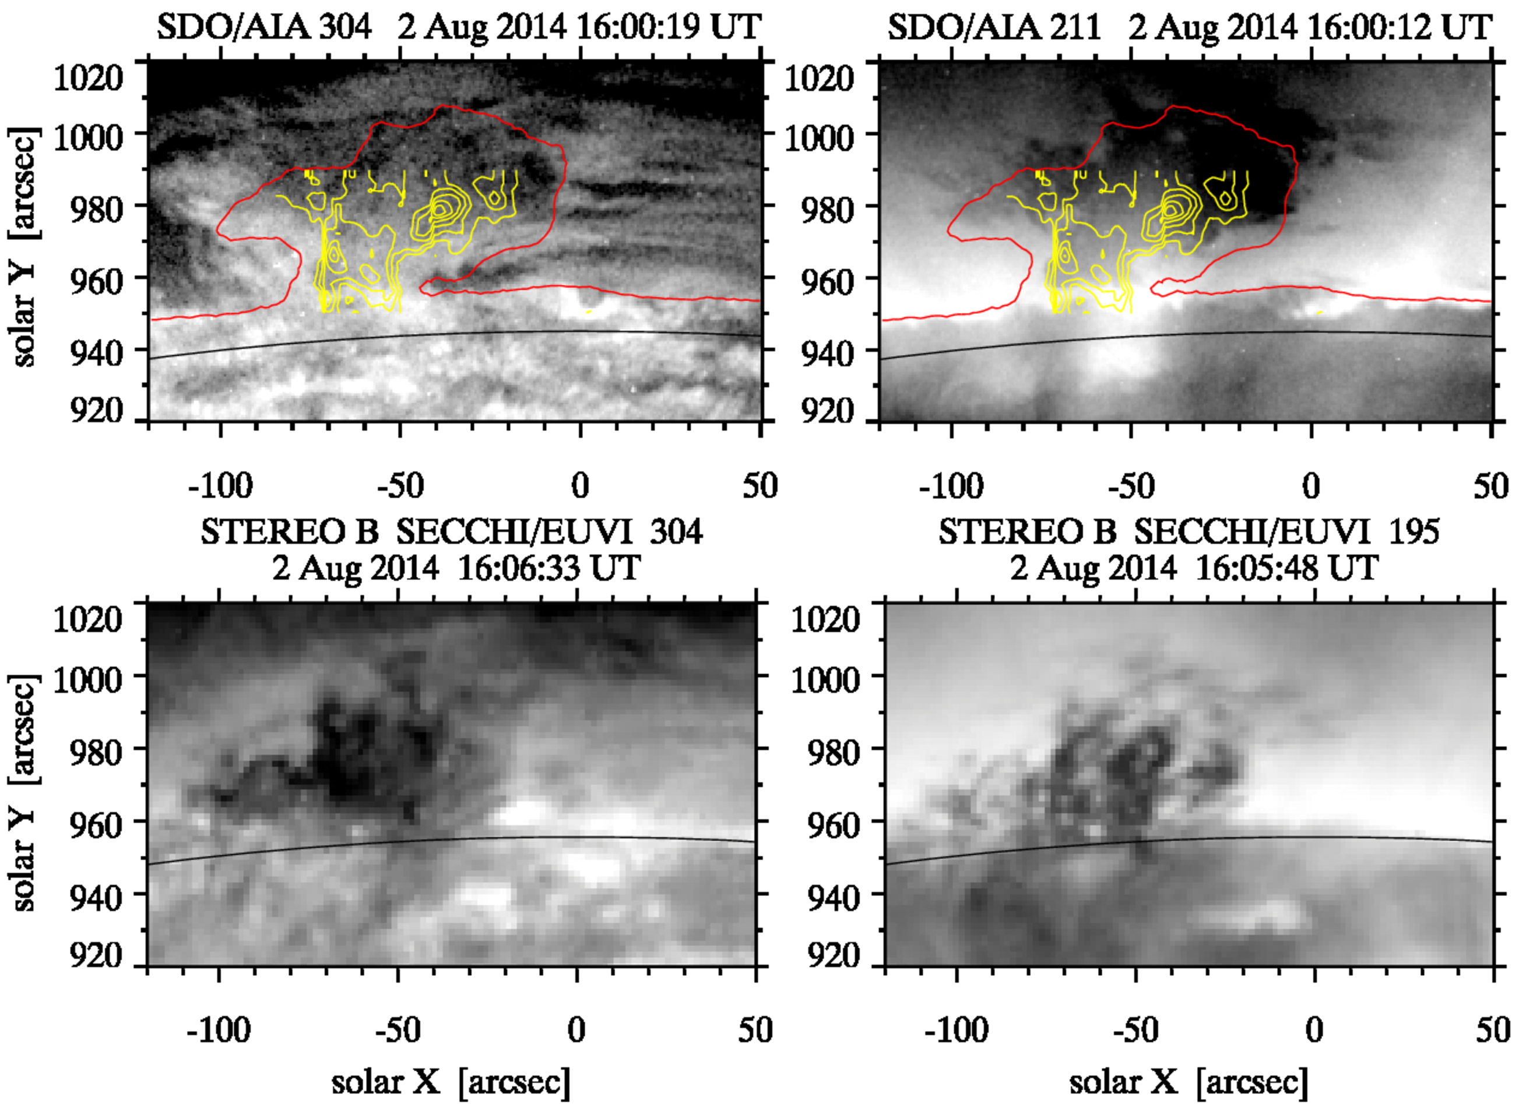
Figure 3. Top: The SDO/AIA images of the quiescent solar prominence, which occurred at the east solar limb on 2 August 2014, in the 304 Å (left) and 211 Å (right) passbands. The red and yellow contours mark the selected Hα and He I 5876 Å D3 intensity levels observed by ground-based instruments. The black arc indicates the east photospheric limb. Bottom: STEREO B SECCHI/EUVI images of the prominence in the 304 Å (left) and 195 Å (right) passbands. Since the separation angle of the spacecraft with Earth was 162°, the black arc indicates the west photospheric limb from the spacecraft viewpoint.

